**(By – Kaushik V)**

**1) INTRODUCTION**

We live in a society which gives a lot of importance to the health and insurance coverage for health or medical expenditure is very important. We believe that health is wealth and to predict the cost of insurance is very important as expenses and cost of insurance differs from person to person based on their sex, age, smoker and non-smoker, region they live etc.

**1.1) Overview**

In this project, age, sex, smoker and other factors have been considered as insurance/medical cost differs from person to person. The major reason to consider the above is that a smoker need to have better medical expense coverage than a non-smoker and a females have better exposure towards expenses hence, it can differ. The process is designed in a such a way that the program can understand different parameters of a person and determine the cost of Insurance.

**1.2) Purpose**

The main purpose of this project is to understand and evaluate the cost of each health/medical insurance of a person based on different parameters used in the program. It is made sure that the insurance company will get the exact data about the person and his health coverage.

2) Literature survey

It is very important to conduct a literature survey before coming to a conclusion regarding any project or file. Below are some of the works to determine the exact details.

2.1) Existing problem

The present problem with the medical/insurance industry is that

1 - They are not able to determine the exact the cost of insurance

2 – sometimes less cost or more cost is allocated at different instances assuming the disease to be more or less

To avoid the above problem, the below model is designed for more efficiency and proficiency.

2.2) proposed solution

The solution for the above is simple and well organised. Every data used in this is made such that it can be easily be differentiated based on different categories like age, sex, smoker etc… such that it is easy for to calculate based on these parameters for cost prediction. It is ensured that expectation of the client is met every time they invest in their company.

3) Theoretical analysis

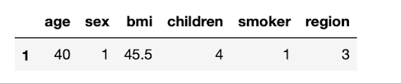

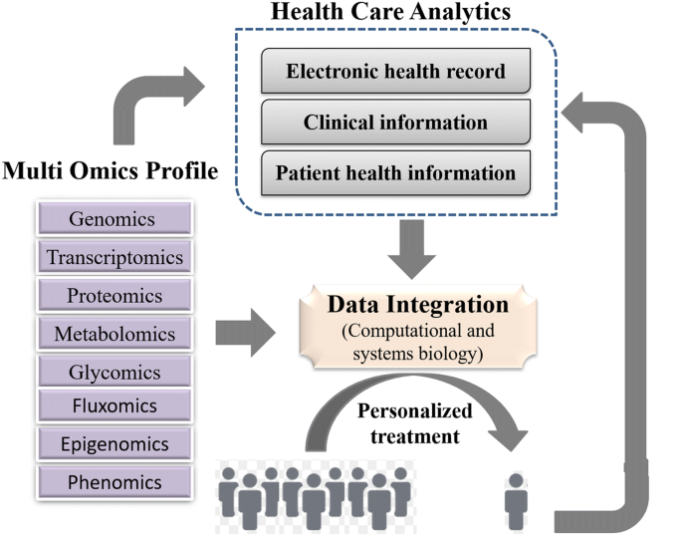

Result

It is clear from the above that the data obtained is in systematic manner and the output is as attached below.

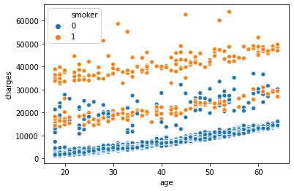(Output)

EXPERIMENTAL INVESTIGATIONS

Initially it was investigated how a cost to the company or insurance cost is calculated.

Later its disadvantages were listed down to know how it can be solved using the above method

Given that all the data is used for calculating the cost, efficiency of the system was a major concern.

Below is the list of websites considered for investigations

1 - <https://www.googleadservices.com/pagead/aclk?sa=L&ai=DChcSEwj83uDs0antAhXMDSsKHY5_AOAYABAAGgJzZg&ae=2&ohost=www.google.co.in&cid=CAESQOD2HDVT9oeviTpsxr9a2rQGnYdk2AXfuLr3iq-awZRoPKt_c7Djy_fK57v3_pTGTjJkWkxPdubkH1WK16n3rMY&sig=AOD64_2yOaXs__8Yin5gjZ9P_Q4n8vPU_w&q&adurl&ved=2ahUKEwjew9js0antAhXBzDgGHWiXBWMQ0Qx6BAgGEAE>

2-https://medium.com/@BAYUGALIH/prediction-of-health-insurance-costs-with-linear-regression-8fd95a905a40

The above link will give a clear idea behind this project.

Advantages and Disadvantages –

Advantages –

1 – Can be used in medical field and business field due to its wide applications.

2- better service to clients as they are accountable to their clients regarding cost.

3- maid available to everyone and get a clear idea if what should a person pay for their coverage.

4- crystal clear data to avoid malpractice

5- Give unbiased data regarding cost and category of people.

6- Give advice on how to improvise their health based on data obtained

7- Coverage of unexpected expenses due to health issues.

8- Avoid situations of excess or less investments for health insurance.

9- Consultation based on data.

10- Graph to obtain predicted value.

Disadvantages –

1- Not all data is considered while evaluating.

2- data which is complicated and includes medical terms cannot be included in calculation.

3- The life expectancy of a person living in different country will differ. Hence, this factor is not considered.

4- System cannot predict immediate deaths and is a loss to the company in that case.

Applications –

1- Extensively used in medical field and health insurance prediction industry

2- Used in field requiring exact determination of cost.

3- Give a clear idea regarding the medicine cost of the patient.

Conclusion- -

There are a lot of methods used to determine the above but using ML is an efficient and cost-effective method. Each data entered should be right such that appropriate data can be obtained. The data includes various inputs which are important for analysis. Data apart from these inputs cannot be determined.

Future scope

This project has a lot of future scope in terms of medical and insurance terms. They are designed in such a way that with limited data, each value can be predicted and output can be determined. Its application is not only limited to medical but also can be extended to defence and essentials field. Proper advice regarding health and diet can also be given using the above data. Awareness programs can be conducted using the above data. Given that all the inputs are present, more complicated systems can be designed to make sure that more appropriate data can be obtained.

Any company can reduce the cost of consultation by using the above method and made sure that flexible advice is given. This model can further be used to predict other things like medicine, food , natural calamities based on the dataset given to it.

Its application is vast and its upon us how well we use it to bring it into practice.

Output screen - -

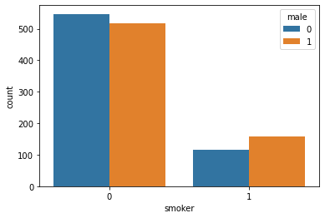

Flow chart regarding inclusion and exclusion of data - -

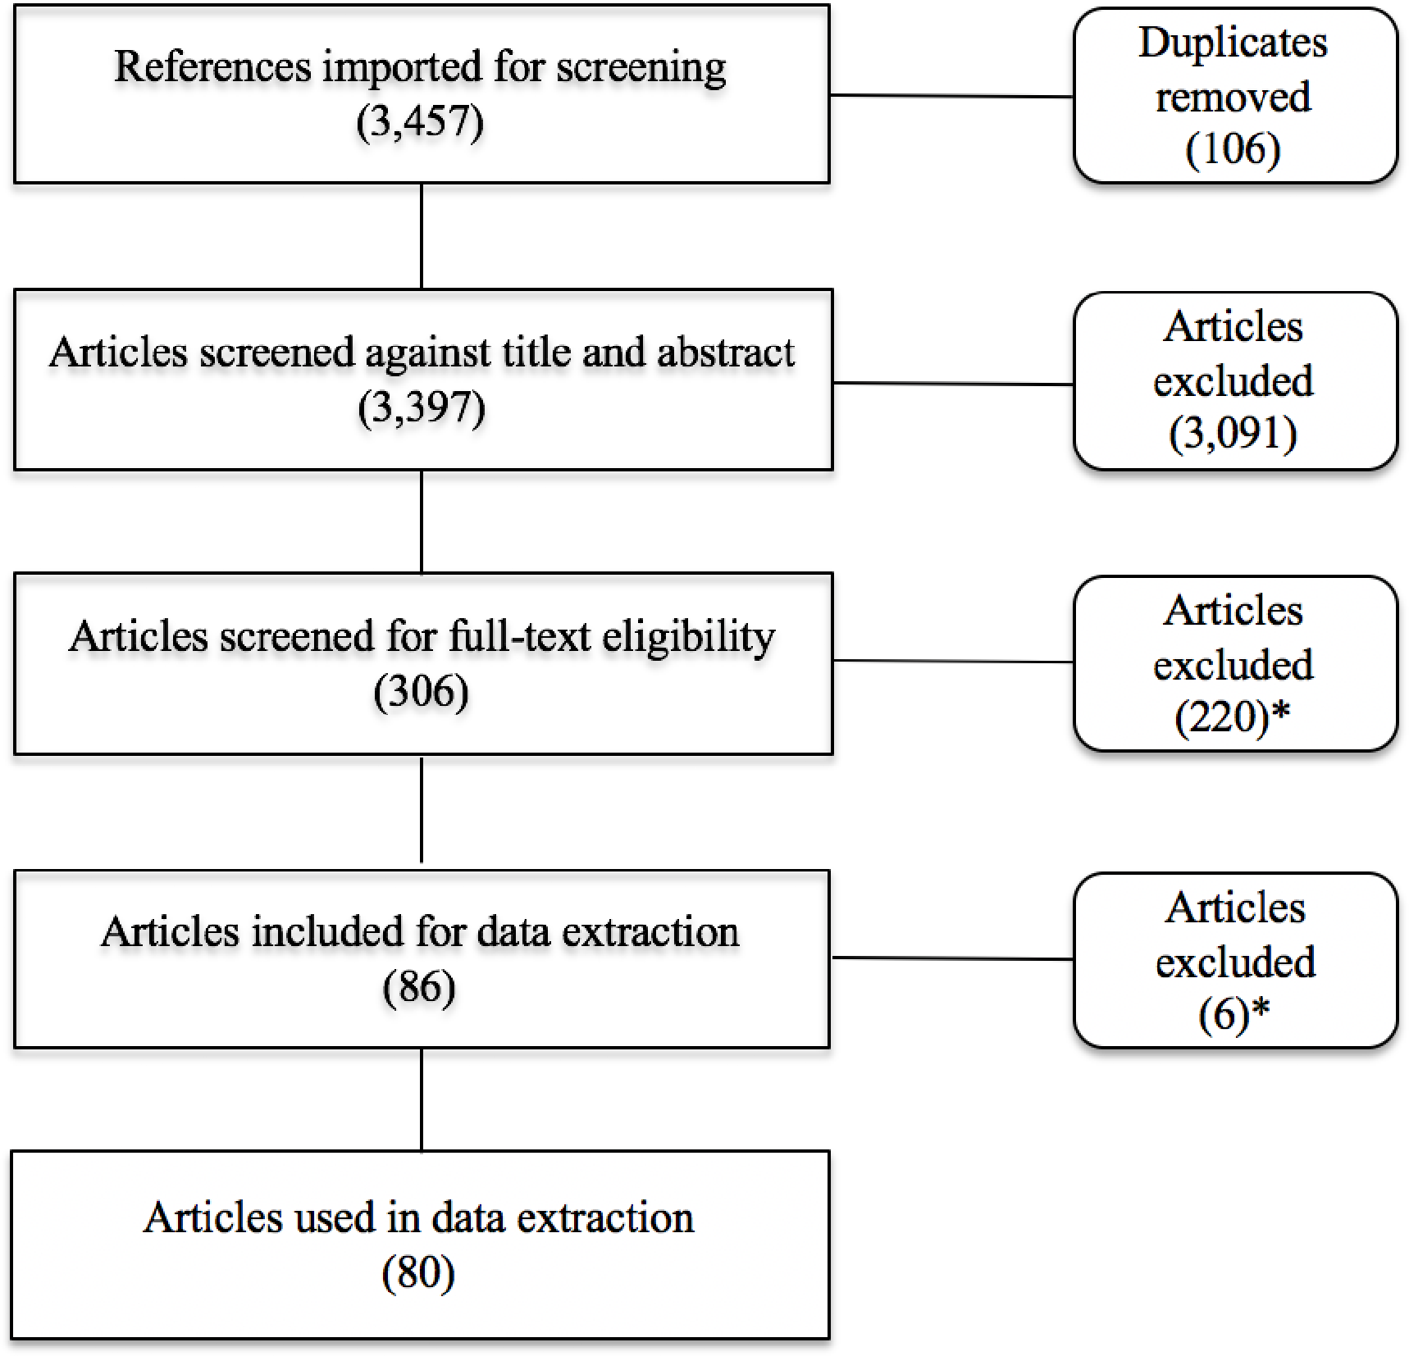

Flowchart –

Below is a flow chat which can be considered as a reference for age, gender and cost when it comes to prediction.

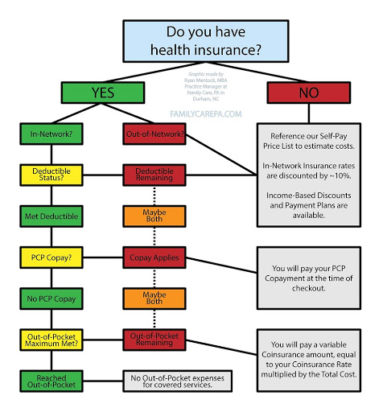

-0-